**Promotion Form Automation**

1. **Introduction:**

In this POC, we aim to automate the creation of promotion form(s). We use a python script that takes data from a spread sheet and renders a word document based on the template we have already designed.

1. **Process**:

We install **docxtpl** using python package management system. Further this package uses 2 major packages:

* python-docx for reading, writing and creating sub documents
* jinja2 for managing tags inserted into the template docx

python-docx-template has been created because python-docx is powerful for creating documents but not for modifying them.

The idea is to begin to create an example of the document you want to generate with Microsoft word, it can be as complex as you want: pictures, index tables, footer, header, variables, anything you can do with word. Then, as you are still editing the document with Microsoft word, you insert jinja2-like tags directly in the document. You save the document as a .docx file (xml format): it will be your .docx template file.

1. **Template**:

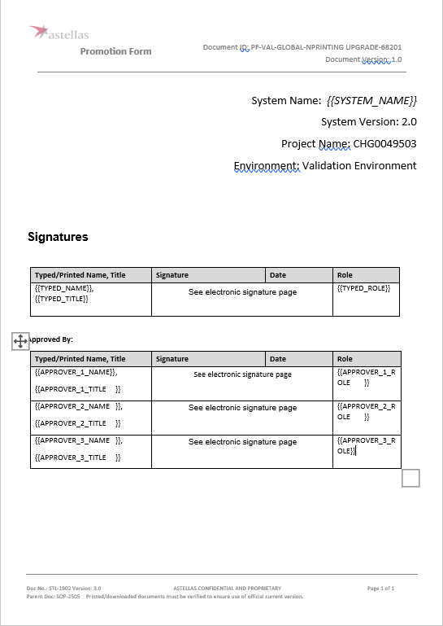

1. **Generated Form:**

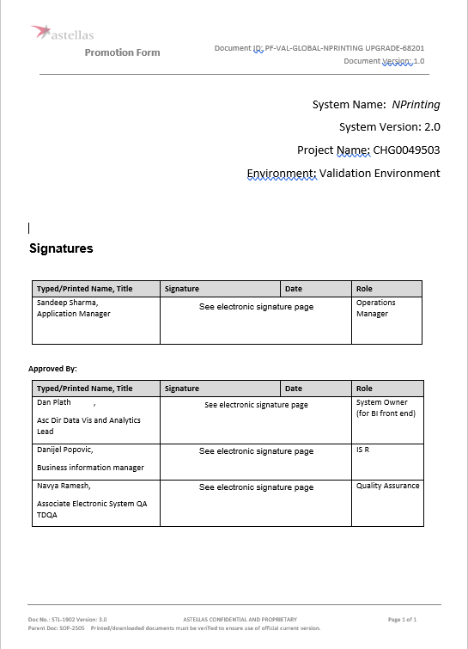

1. **Spreadsheet Data:**

|  |  |  |
| --- | --- | --- |
| **TYPED_NAME** | **TYPED_TITLE** | **TYPED_ROLE** |
| Sandeep Sharma | Application Manager | Operations Manager |

|  |
| --- |
| **SYSTEM_NAME** |
| NPrinting |

|  |  |  |
| --- | --- | --- |
| **APPROVER_1_NAME** | **APPROVER_1_TITLE** | **APPROVER_1_ROLE** |
| Dan Plath | Asc Dir Data Vis and Analytics Lead | System Owner (for BI front end) |

|  |  |  |
| --- | --- | --- |
| **APPROVER_2_NAME** | **APPROVER_2_TITLE** | **APPROVER_2_ROLE** |
| Danijel Popovic | Business information manager | IS R&C |

|  |  |  |
| --- | --- | --- |
| **APPROVER_3_NAME** | **APPROVER_3_TITLE** | **APPROVER_3_ROLE** |
| Navya Ramesh | Associate Electronic System QA TDQA | Quality Assurance |

1. **Conclusion:**

With formatted templates and appropriate data, we can automate and render the promotion forms within minutes, saving redundant manual labour.